Accounting Seed is a complete accounting solution built natively on Salesforce, the world’s leading business process automation platform. Connect all your critical business data and processes on one platform from sales lead to general ledger and imagine the massive efficiencies gained, with automated entries accounting entries, collections and payments. Accounting Seed works with over 14,500 banks and credit card companies as well as Salesforce apps—including Sales Cloud, Service Cloud, Nonprofit Success Pack, Field Service Lightning, and more—all without costly integrations.

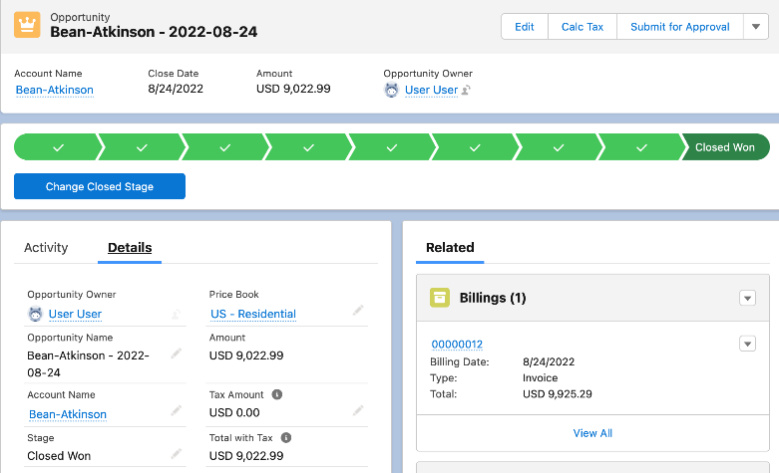
A SINGLE SOURCE OF TRUTH

Easily set up and automate your entire business on one platform.
With Accounting Seed, you will gain complete visibility across your business, and be able to:
- Run your business from one system with CRM & Accounting together.
- Gain real-time insights into business performance from sales, operations, and finance.
- Unlock automation and workflows to reduce errors and manual entry.
- Adapt, scale and tailor accounting processes to your business.
- Work within a world-class cloud platform with top security.

AN END-TO-END SOLUTION FOR YOUR UNIQUE BUSINESS
Connect financial data across your entire business.
As a trusted Salesforce partner for over a decade, organizations have relied on Accounting Seed to deliver impactful financial data to support their businesses in real-time. With the power of Accounting Seed and Ayodia you can streamline your organization and maximize efficiency. Embrace the unique way you do business leveraging a dynamic solution that adapts and grows with your business. Read the reviews.

[INSERT PARTNER CALL TO ACTION]
[Insert partner info/closing here]

